**S-130**



Published by the

International Hydrographic Organization

4b quai Antoine 1er

Principauté de Monaco

Tel: (377) 93.10.81.00

Fax: (377) 93.10.81.40

info@iho.int

www.iho.int

**POLYGONAL DEMARCATIONS OF GLOBAL SEA AREAS**

**Edition 2.0.0-20250320**

|  |
| --- |
| © Copyright International Hydrographic Organization March 2025 |
| This work is copyright. Apart from any use permitted in accordance with the [Berne Convention for the Protection of Literary and Artistic Works](http://www.wipo.int/treaties/en/ip/berne/trtdocs_wo001.html) (1886), and except in the circumstances described below, no part may be translated, reproduced by any process, adapted, communicated or commercially exploited without prior written permission from the International Hydrographic Organization Secretariat (IHO Secretariat). Copyright in some of the material in this publication may be owned by another party and permission for the translation and/or reproduction of that material must be obtained from the owner. |
| This document or partial material from this document may be translated, reproduced or distributed for general information, on no more than a cost recovery basis. Copies may not be sold or distributed for profit or gain without prior written agreement of the IHO Secretariat acting for the IHO and any other copyright holders. |
| In the event that this document or partial material from this document is reproduced, translated or distributed under the terms described above, the following statements are to be included: |
| *“Material from IHO publication [reference to extract: Title, Edition] is reproduced with the permission of the International Hydrographic Organization Secretariat (IHO Secretariat) (Permission No ……./…) acting for the International Hydrographic Organization (IHO), which does not accept responsibility for the correctness of the material as reproduced: in case of doubt, the IHO’s authentic text shall prevail. The incorporation of material sourced from IHO shall not be construed as constituting an endorsement by IHO of this product.”* |
| *“This [document/publication] is a translation of IHO [document/publication] [name]. The IHO has not checked this translation and therefore takes no responsibility for its accuracy. In case of doubt the source version of [name] in [language] should be consulted.”*  The IHO Logo or other identifiers shall not be used in any derived product without prior written permission from the IHO Secretariat. |

**Revision History**

Changes to this Product Specification are coordinated by the IHO. New editions will be made available via the IHO website. Maintenance of the Product Specification must conform to IHO Technical Resolution 2/2007 as amended.

|  |  |  |  |
| --- | --- | --- | --- |
| **Version Number** | **Date** | **Author** | **Purpose** |
| 0.0.1 | 06-Jan-2023 | S-130 PT | Skeleton is proposed for the Editing Sub-Group |
| 0.0.2 | 31-Jan-2023 | S-130PT | Revision by Editing Sub-Group |
| 0.0.3 | 24-Feb-2023 | S-130PT | Revision by Editing Sub-Group after meeting |
| 0.0.4 | 03-Apr-2023 | S-130PT | Changes made in accordance with S-130PT5 decisions |
| 1.0.0 | 14-Apr-2023 | S-130PT | Release 1.0.0 |
| 1.1.0 | 29-Nov-2023 | S-130PT | Changes made in accordance with S-130PT6 decisions |
| 1.1.0 | 09-Apr-2024 | S-130PT | Release 1.1.0 |
| 2.0.0 | 17-Feb-2025 | S-130PT | Changes made in accordance with S-130PT9, S-130 PT10, S-130 TG VTC (31 Jan. 2025), and alignment with S-100 Edition 5.2.0. |
| 2.0.0 | 16-Mar-2025 | RM | Apply changes decided at S-130 PT11 and after |
| 2.0.0 | 20-Mar-2025 | S-130PT | HSSC Final Draft |
|  |  |  |  |
|  |  |  |  |

TABLE OF CONTENTS

1. Overview 1

1.1. Introduction 1

1.2. References 1

1.2.1. Normative 1

1.2.2. Informative 1

1.3. Terms, Definitions and Abbreviations 2

1.3.1. Terms and Definitions 2

1.3.2. Abbreviations 4

1.4. Use of Language 4

1.5. UML Notations 4

1.6. Informal Description of Data Product 4

1.7. Data product specification metadata 5

1.8. Product Specification Maintenance 5

1.8.1. Introduction 5

1.8.2. New Edition 5

1.8.3. Revisions 6

1.8.4. Clarification 6

1.8.5. Version Numbers 6

2. Specification Scope 6

3. Data product identification 7

4. Data Content and Structure 7

4.1. Introduction 7

4.2. Application Schema 8

4.2.1. Multipolygonal areas 10

5. Feature Catalogue 11

5.1. Introduction 11

5.2. Feature Types 11

5.2.1. Geographic 12

5.2.2. Meta 12

5.2.3. Feature Relationship 12

5.2.4. Information Types 12

5.2.5. Attributes 12

5.3. Complex Attributes 13

5.4. Units of Measure 13

5.5. Geometric Representation 13

6. Coordinate Reference System (CRS) 13

6.1.1. Horizontal reference system 13

6.1.2. Projection 14

6.1.3. Temporal reference system 14

6.1.4. Polygonal Demarcations of Global Sea Areas data and scale 14

7. Data quality 14

7.1. Introduction to data quality 14

7.2. Completeness 15

7.2.1. Commission 15

7.2.2. Omission 15

7.3. Logical Consistency 15

7.3.1. Conceptual Consistency 15

7.3.2. Domain Consistency 15

7.3.3. Format Consistency 16

7.3.4. Topological Consistency 16

7.4. Positional Uncertainty and Accuracy 16

7.4.1. Vertical Position Accuracy 16

7.4.2. Horizontal Position Accuracy 16

7.4.3. Gridded Data Positional Accuracy 16

7.5. Thematic Accuracy 17

7.5.1. Thematic Classification Correctness 17

7.5.2. Non-Quantitative Attribute Accuracy 17

7.5.3. Quantitative Attribute Accuracy 17

7.6. Temporal Quality 17

7.6.1. Temporal Consistency 17

7.6.2. Temporal Validity 17

7.6.3. Temporal Accuracy 17

7.7. Aggregation 17

7.8. Quality measure elements 17

8. Data Capture and Classification 21

8.1. Data Encoding and Product Delivery 21

8.1.1. Data Encoding 21

8.1.2. Types of Datasets 21

8.1.3. Data Format for Update Datasets 21

8.1.4. Data Format for Cancellation Datasets 22

8.2. Numeric Attribute Encoding 22

8.3. Text Attribute Values 22

8.4. Mandatory Attribute Values 22

8.5. Unknown Attribute Values 22

8.6. Structure of dataset files 23

8.6.1. Sequence of objects 23

8.7. Object identifiers 23

8.8. Data coverage 23

8.9. Data overlap 23

9. Data Delivery 24

9.1. Data Product Delivery Information 24

9.1.1. New editions 24

9.2. Exchange Set 24

9.2.1. Components of the exchange set 24

9.2.2. Exchange set structure 25

9.3. Dataset Naming Convention 27

9.4. Support File Naming Convention 27

10. Data Maintenance 28

10.1. Introduction 28

10.2. Production process for base and update datasets 28

10.3. Dataset updates and cancellation 28

10.4. Support file updates 29

10.5. Feature catalogues 29

10.6. Feature history, versions and change tracking 29

11. Portrayal 29

12. Metadata 29

12.1. Introduction 29

12.2. Elements of S-130 Exchange Catalogues 30

12.2.1. S100_ExchangeCatalogue 32

12.2.2. S100_ExchangeCatalogueIdentifier 33

12.2.3. S100_CataloguePointofContact 33

12.2.4. S100_DatasetDiscoveryMetadata 33

12.2.5. S100_SupportFileDiscoveryMetadata 40

12.2.6. S100_CatalogueDiscoveryMetadata 43

12.2.7. PT_Locale 43

12.2.8. S100_SE_CertificateContainer 43

LIST OF ANNEXES 44

# Overview

## Introduction

This document describes a product specification for the Polygonal Demarcations of Global Sea Areas (PDGSA). It is a vector product specification that is primarily intended for encoding the extent of global sea areas using a system of unique numerical identifiers only. This product specification complies with the IHO S-100 Universal Hydrographic Data Model.

## References

### Normative

The following normative documents contain provisions that, through reference in this text, constitute provisions of this document.

IHO S-100 IHO Universal Hydrographic Data Model Edition 5.2.0 (June 2024)

ISO 8601:2004 Data elements and interchange formats – Information interchange – Representation of dates and times

ISO 3166-1:2020 Country Codes

ISO/TS 19103:2005 Geographic Information – Conceptual schema language

ISO 19106:2004 Geographic Information – Profiles

ISO 19107:2003 Geographic Information – Spatial schema

ISO 19108:2002 Geographical Information – Temporal Schema (as corrected by Technical Corrigendum 1 – 2006)

ISO 19109:2005 Geographic Information – Rules for application schema

ISO 19110:2005 Geographic information – Methodology for feature cataloguing

ISO 19111:2003 Geographic Information – Spatial referencing by coordinates

ISO 19115-1:2018 Geographic information – Metadata – Part 1 – Fundamentals. As amended by Amendment 1, 2018

ISO 19115-3:2016 Geographic information – Metadata - XML schema implementation for fundamental concepts, 2016

ISO 19131:2007 Geographic Information – Data product specifications

ISO 19136:2007 Geographic Information – Geography Markup Language

ISO 19136-2:2015 Geographic Information – Geography Markup Language

ISO 639-2:1998 Codes for the representation of names of languages -- Part 2: Alpha-3 code

ISO/IEC 10646:2017 Information Technology – Universal Coded Character Set (UCS)

RFC 2141 URN Syntax. R. Moats. IETF RFC 2141, May 1997. URL: https://www.ietf.org/rfc/rfc2141.txt

### Informative

The following informative documents provide additional information, including background information or definitions, but are not required to develop applications for data conforming to this specification.

ISO 19115:2003 Geographic Information – Metadata, As corrected by Corr1 (2006)

ISO/IEC 19757-3 Information technology – Document Schema Definition Languages (DSDL) – Part 3: Rule-based validation – Schematron

IHO S-101 IHO Electronic Navigational Chart Product Specification Edition 2.0.0 (December 2024)

## Terms, Definitions and Abbreviations

### Terms and Definitions

The S-100 framework is based on the ISO 19100 series of geographic standards. The terms and definitions provided here are used to standardize the nomenclature found within that framework, whenever possible. They are taken from the references cited in clause 1.2. Modifications have been made when necessary.

**application**

manipulation and processing of data in support of user requirements (ISO 19101)

**application schema**

**conceptual schema** for data required by one or more **applications** (ISO 19101)

**composite curve**

sequence of curves such that each curve (except the first) starts at the end point of the previous curve in the sequence (ISO 19107)

**conceptual model**

modelthat defines concepts of a **universe of discourse** (ISO 19101)

**conceptual schema**

formal description of a **conceptual model** (ISO 19101)

**curve**

1-dimensional geometric primitive, representing the continuous image of a line

*NOTE: The boundary of a curve is the set of points at either end of the curve. If the curve is a cycle, the two ends are identical, and the curve (if topologically closed) is considered to not have a boundary. The first point is called the start point, and the last is the end point. Connectivity of the curve is guaranteed by the “continuous image of a line”.*

**data product**

**dataset** or **dataset series** that conforms to a **data product specification** (ISO 19131)

**data product specification**

detailed description of a **dataset** or **dataset series** together with additional information that will enable it to be created, supplied to and used by another party (ISO 19131)

*NOTE: A data product specification provides a description of the universe of discourse and a specification for mapping the universe of discourse to a dataset. It may be used for production, sales, end-use or other purpose.*

**dataset**

identifiable collection of data (ISO 19115)

*NOTE: A dataset may be a smaller grouping of data which, though limited by some constraint such as spatial extent or feature type, is located physically within a larger dataset. Theoretically, a dataset may be as small as a single feature or feature attribute contained within a larger dataset. A hardcopy map or chart may be considered a dataset.*

**dataset series**

collection of **datasets** sharing the same product specification (ISO 19115)

**domain**

well-defined set (ISO/TS 19103)

*NOTE: Well-defined means that the definition is both necessary and sufficient, as everything that satisfies the definition is in the set and everything that does not satisfy the definition is necessarily outside the set.*

**feature**

abstraction of real-world phenomena (ISO 19101)

*NOTE: A feature may occur as a type or an instance. Feature type or feature instance shall be used when only one is meant.*

**feature association**

relationship that links instances of one **feature** type with instances of the same or a different **feature** type (ISO19110)

*NOTE 1: A feature association may occur as a type or an instance. Feature association type or feature association instance is used when only one is meant.*

*NOTE 2: Feature associations include aggregation of features.*

**feature attribute**

characteristic of a **feature** (ISO 19101)

*NOTE 1: A feature attribute may occur as a type or an instance. Feature attribute type or feature attribute instance is used when only one is meant.*

*NOTE 2: A feature attribute type has a name, a data type and a domain associated to it. A feature attribute for a feature instance has an attribute value taken from the domain.*

**geographic data**

data with implicit or explicit reference to a location relative to the Earth (ISO 19109)

*NOTE: Geographic information is also used as a term for information concerning phenomena implicitly or explicitly associated with a location relative to the Earth.*

**metadata**

data about data (ISO 19115)

**model**

abstraction of some aspects of reality (ISO 19109)

**point**

0-dimensional geometric primitive, representing a position

*NOTE The boundary of a point is the empty set.*

**quality**

totality of characteristics of a product that bear on its ability to satisfy stated and implied needs (ISO 19101)

**surface**

connected 2-dimensional geometric primitive, representing the continuous image of a region of a plane

NOTE: The boundary of a surface is the set of oriented, closed curves that delineate the limits of the surface.

**universe of discourse**

view of the real or hypothetical world that includes everything of interest (ISO 19101)

### Abbreviations

This product specification adopts the following convention for symbols and abbreviated terms:

ASCII American Standard Code for Information Interchange  
GML Geography Markup Language  
IHO International Hydrographic Organization  
IOC Intergovernmental Oceanographic Commission  
ISO International Organization for Standardization  
UML Unified Modelling Language  
URI Uniform Resource Identifier  
URL Uniform Resource Locator  
WGS World Geodetic System  
XML eXtensible Markup Language  
XSLT eXtensible Stylesheet Language Transformations

## Use of Language

Within this document, including appendices and annexes:

* “Must” indicates a mandatory requirement.
* “Should” indicates an optional requirement, that is the recommended process to be followed, but is not mandatory.
* “May” means “allowed to” or “could possibly”, and is not mandatory.

## UML Notations

In this document, conceptual schemas are presented in the Unified Modelling Language (UML). Several model elements used in this schema are defined in ISO standards or in IHO S-100 documents. In order to ensure that class names in the model are unique ISO TC/211 has adopted a convention of establishing a prefix to the names of classes that define the TC/211 defined UML package in which the UML class is defined. The IHO standards and this product specification make use of classes derived directly from the ISO standards. This convention is also followed in this document. In the IHO standards class names are identified by the name of the standard, such as "S-100" as the prefix optionally followed by the bi-alpha prefix derived from ISO standard. In order to avoid having multiple classes instantiating the same root classes, the ISO classes and S-100 classes have been used where possible; however, a new instantiated class is required if there is a need to alter a class or relationship to prevent a reverse coupling between the model elements introduced in this document and those defined in S-100 or the ISO model.

## Informal Description of Data Product

This clause contains general information about the data product.

**Title:** Polygonal Demarcations of Global Sea Areas

**Abstract:** Polygonal Demarcations of Global Sea Areas (PDGSA) datasets support the provision of digital coordinates for limits of oceans and seas to meet the requirements of contemporary geographic information systems. It is a vector product specification that is primarily intended for encoding the extent of global sea areas using a system of unique numerical identifiers only.

**Content:** Datasets conforming to this specification will contain all relevant limits of oceans and seas.

**Spatial Extent:** Global coverage of sea areas.

**Specific Purpose:** Provision of digital coordinates for limits of oceans and seas to meet the requirements of contemporary geographic information systems.

## Data product specification metadata

This information uniquely identifies this Product Specification and provides information about its creation and maintenance. For further information on dataset metadata see the metadata clause.

**Title:** Polygonal Demarcations of Global Sea Areas

**S-100 Version:** 5.2.0

**S-130 Version**: 2.0.0

**Date**: 2025-03-20

**Language**: English

**Classification**: Unclassified

**Contact**: International Hydrographic Organization,   
 4 quai Antoine 1er,  
 B.P. 445  
 MC 98011 MONACO CEDEX  
 Telephone: +377 93 10 81 00  
 Telefax: + 377 93 10 81 40

**URL**: https://iho.int

**Identifier**: S-130

**Maintenance**: Amendments to this specification will be produced on a needs basis. For reporting issues with this specification which need correction, use the contact information.

## Product Specification Maintenance

### Introduction

Changes to S-130 will be released by the IHO as a new edition, a revision, or as a document that includes clarification. These are described below.

### New Edition

New Editions introduce significant changes. New Editions enable new concepts, such as the ability to support new functions or applications, or the introduction of new constructs or data types. New Editions are likely to have a significant impact on either existing users or future users of S-130.

### Revisions

Revisions are defined as substantive semantic changes. Typically, revisions will introduce changes to correct factual errors or introduce necessary changes that have become evident as a result of practical experience or changing circumstances. A revision must not also be classified as a clarification. Revisions could have an impact on either existing users or future users of this specification. All cumulative clarifications will be included with the release of approved corrections revisions.

Changes in a revision are minor and ensure backward compatibility with the previous versions within the same Edition. Newer revisions, for example, introduce new features and attributes. Within the same Edition, a dataset of one version could always be processed with a later version of the feature catalogues. In most cases a new feature catalogue will result in a revision of this specification.

### Clarification

Clarifications are non-substantive changes. Typically, clarifications remove ambiguity; correct grammatical and spelling errors; amend or update cross references; insert improved graphics, spelling, punctuation and grammar. Clarifications must not cause any substantive semantic changes.

Changes in a clarification are minor and ensure backward compatibility with the previous versions within the same Edition. Within the same Edition, a dataset of one clarification version could always be processed with a later version of the feature catalogue.

### Version Numbers

The associated version control numbering to identify changes (n) to this specification must be as follows:

New Editions denoted as **n**.0.0

Revisions denoted as n.**n**.0

Clarifications denoted as n.n.**n**

# Specification Scope

This product specification describes one data product and therefore requires only one scope which is described below:

**Scope ID:** Polygonal Demarcations of Global Sea Areas

**Hierarchical level:** MD_ScopeCode – 005 (dataset)

**Hierarchical level name:** dataset

**Level description:** information applies to the dataset

**Extent:** EX_Extent.description: Global coverage of sea areas

# Data product identification

This section describes how to identify data sets that conform to the specification. A dataset that conforms to this Product Specification may be identified by its discovery metadata as defined in clause 14 of this specification. The information identifying the data product may include the following items from S-100 5.2.0 clause 11-6 (adapted from ISO 19115).

|  |  |
| --- | --- |
| **Title** | Polygonal Demarcations of Global Sea Areas |
| **Abstract** | Polygonal Demarcations of Global Sea Areas (PDGSA) datasets support the provision of digital coordinates for limits of oceans and seas to meet the requirements of contemporary geographic information systems. It is a vector product specification that is primarily intended for encoding the extent of global sea areas using a system of unique numerical identifiers only. |
| **Acronym** | PDGSA |
| **Content** | Datasets conforming to this specification will contain all relevant limits of oceans and seas. |
| **GeographicDescription** | **EX_GeographicBoundingBox**: bounding coordinates of the maximum geospatial extent in decimal degrees |
| **SpatialResolution** | MD_Resolution>equivalentScale.denominator (integer) or MD_Resolution>levelOfDetail (CharacterString). E.g.: “All scales” |
| **Purpose** | Provision of digital coordinates for limits of oceans and seas to meet the requirements of contemporary geographic information systems, and to allow the producer to exchange global limit of oceans and seas information with interested stakeholders. |
| **Language** | EN  Additional values, if any, use CharacterString values from ISO 639-2 |

# Data Content and Structure

## Introduction

The S-130 product is based on the S-100 General Feature Model (GFM), and is a feature-based vector product. The S-130 feature classes are derived from the abstract class **FeatureType** in the S-130 application schema, which realizes the GFM meta-class **S100_GF_FeatureType**.

S-130 features are encoded as vector entities which conform to S-100 geometry configuration level 3a/b (S-100 section 7-4.3.5) as encoded using S-100 Part 10b.

This section contains the Application Schema expressed in UML and an associated Feature Catalogue. The Feature Catalogue is included in Annex C, and provides a full description of each feature type including its attributes, attribute values and relationships in the data product.

## Application Schema

The UML model shown below is the overall S-130 application schema, and includes overviews of the feature classes, information classes, spatial types, and the relationships between them.

This contains a general overview of the classes and relationships in the S-130 application schema. Detailed information about how to use the feature types and information types to encode PDGSA (Polygonal Demarcations of Global Sea Areas) information is provided in the S-130 Data Classification and Encoding Guide (DCEG).

The following conventions are used in the UML diagrams depicting the application schema:

* Standard UML conventions for classes, associations, inheritance, roles, and multiplicities apply. These conventions are described in Part 1 of S-100.
* Feature classes are depicted with a green background.
* Information type classes are depicted with a blue background.
* Complex attributes are depicted with a pink background.
* Enumeration lists are depicted with a light green background. The numeric code corresponding to each listed value is shown to its right following an '=' sign.
* No significance attaches to the colour of associations. (Complex diagrams may use different colours to distinguish associations that cross one another.)
* Where the association role or name is not explicitly shown, the default rules for roles and names apply.

The figure below contains all the geographic features in the S-130 application schema with their attributes.

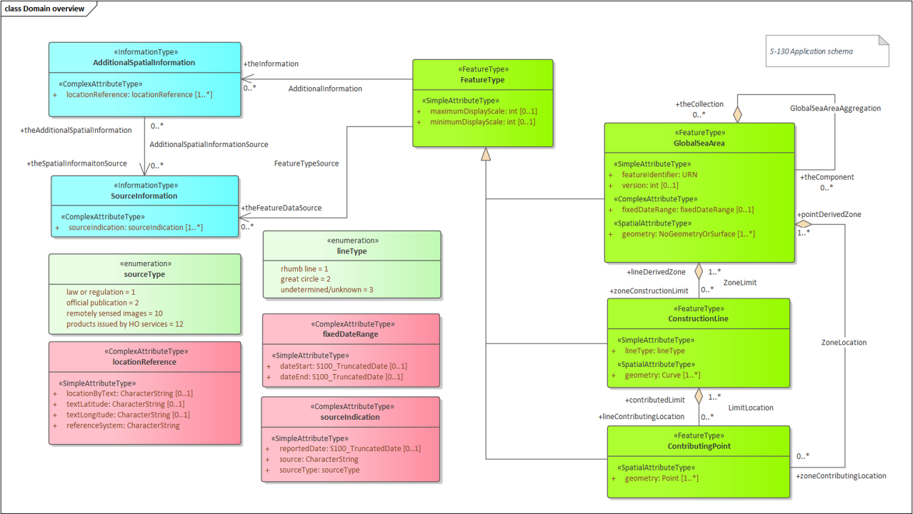

Figure 4-1 – Overview of S-130 Application Schema

Polygonal Demarcations of Global Sea Areas products describe the extents of global seas and oceans and may include a feature identifier, version, display scale range, date range, source indication, and additional spatial information. **FeatureType**, serving as the superclass for other feature types, encompasses common attributes to identify the maximum and minimum display scale(s), essential for visualizing the global sea area layer.

**GlobalSeaArea** serves as the key feature type for encoding the surface of global sea and ocean areas. It encompasses the following attributes: a feature identifier for unique identification, version for change management, and date range indicating the effective feature dates. The complex attribute **fixedDateRange** consists of individual simple attribute types each defined as a separate class. Additionally, **GlobalSeaArea** can be enriched with **ConstructionLine** and **ContributingPoint**. **ConstructionLine**, as a feature type, encodes the curves demarcating global sea and ocean areas, and includes the line type as simple attribute type. **ContributingPoint** is instrumental in encoding the points of global sea areas.

**AdditionalSpatialInformation**, an information type, provides the possibility to include additional spatial information. It incorporates attributes for locations described through text, latitude/longitude expressed in text format, and reference systems. Similarly, **SourceInformation,**, another information type, delves into source information, featuring attributes for the reported date, source and source type.

Geographic features adhere to spatial types defined in the geometry package for spatial attributes. The hierarchical organization of geographic features revolves around both feature association and information association.

### Multipolygonal areas

For global sea areas whose spatial extents are multi-polygons. each polygon must be encoded as a distinct **GlobalSeaArea** feature. In addition, an aggregate **GlobalSeaArea** feature must be created with no geometry. All the polygonal features deriving from the same multi-polygonal feature must be associated with the same aggregate **GlobalSeaArea** feature using a **GlobalSeaAreaAggregation** association. The value for *featureIdentifier* must be the same for all the features in each collection; and should be computed from the centroid of the original multi-polygon from which they are derived.

EXAMPLE: In Figure 4-2, the global sea area A must be split into separate **GlobalSeaArea** features having different polygonal spatial primitives but the same *featureIdentifier*, and all such features must be associated to a **GlobalSeaArea** with no geometry and the same *featureIdentifier*.

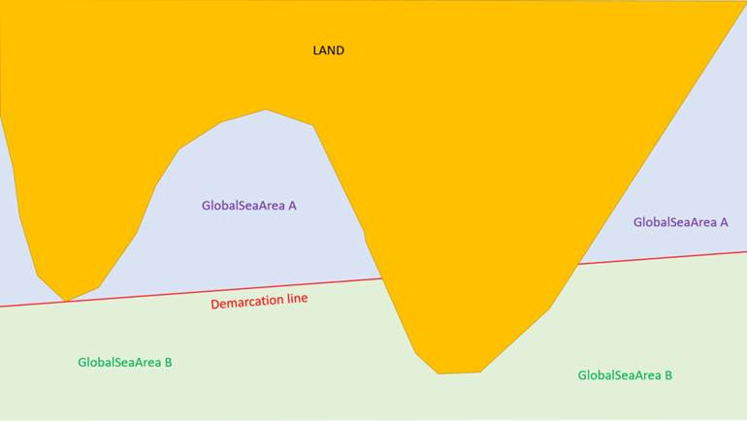

Figure 4-2 – Example of split feature

# Feature Catalogue

## Introduction

The Feature Catalogue describes the feature types, information types, attributes, attribute values, associations and roles which may be used in the product. The S-130 Feature Catalogue is available in an XML document which conforms to the S-100 XML Feature Catalogue Schema and can be downloaded from the IHO Geospatial Information Registry (https://registry.iho.int/main.do). Simple attributes used in this specification are listed as below.

**Name:** Polygonal Demarcations of Global Sea Areas

**Scope:** Ocean, Coastal, Ports, Harbors and Inland waters

**Version Number:** 2.0.0

**Version Date:** 2025-03-20

**Producer:** IHO   
 4 quai Antoine 1er,  
 B.P. 445  
 MC 98011 MONACO CEDEX  
 Telephone: +377 93 10 81 00  
 Telefax: + 377 93 10 81 40

URL https://iho.int

**Language:** English

## Feature Types

Feature types contain descriptive attributes that characterize real-world entities. The word ‘feature’ may be used in one of two senses – feature type and feature instance. A feature type is a class and is defined in a Feature Catalogue. A feature instance is a single occurrence of the feature type and represented as an object in a dataset. A feature instance is located by a relationship to one or more spatial instances. A feature instance may exist without referencing a spatial instance.

### Geographic

Geographic (Geo) feature types carry the descriptive characteristics of a real-world entity.

### Meta

Meta features contain information about other features within a dataset. Information defined by meta features override the default metadata values defined by the dataset descriptive records. Meta attribution on individual features overrides attribution on meta features.

### Feature Relationship

A feature relationship links instances of one feature type with instances of the same or a different feature type.

### Information Types

Information types are identifiable pieces of information in a dataset that can be shared between other features. They have attributes but have no relationship to any geometry; information types may reference other information types.

### Attributes

S-130 defines attributes as either simple or complex.

#### Simple Attributes

S-130 uses ten types of simple attributes; they are listed in the following table:

|  |  |
| --- | --- |
| **Type** | **Definition** |
| Enumeration | A fixed list of valid identifiers of named literal values |
| Boolean | A value representing binary logic. The value can be either True or False. The default state for Boolean type attributes (i.e. where the attribute is not populated for the feature) is False. |
| Real | A signed Real (floating point) number consisting of a mantissa and an exponent |
| Integer | A signed integer number. The representation of an integer is encapsulation and usage dependent. |
| Text | An arbitrary-length sequence of characters including accents and special characters from a repertoire of one of the adopted character sets |
| Date | A date provides values for year, month and day according to the Gregorian Calendar. In S-130, the character encoding of a date is a string which must conform to the XML Schema standard type instead of the ISO 8601 basic representation (which is not a standard type in XML).  EXAMPLE 1998-09-18 (YYYY-MM-DD) |
| Time | A time is given by an hour, minute and second. In S-130, the character encoding of a time is a string which must conform to the XML Schema standard type instead of the ISO 8601 basic representation (which is not a standard type in XML).  EXAMPLE 18:30:59Z; 18:30:59+01:00; 18:30:59 |
| Codelist | A type of flexible enumeration. A code list type is a list of literals which may be extended only in conformance with specified rules. |
| Truncated date | Allows a partial date to be encoded as an extension to the ISO 8601 compliant date attribute type values for year, month and day according to the Gregorian Calendar. The S-100 truncated date type also allows complete dates to be encoded.  EXAMPLE 1: <S100:date>2018-05-01</S100:date>  EXAMPLE 2: <S100:gYearMonth>2022-04</S100:gYearMonth> |
| URN | A persistent, location-independent, resource identifier that follows the syntax and semantics for URNs specified in RFC 2141. |

Table 5-1 - Simple feature attributes

## Complex Attributes

Complex attributes are aggregations of other attributes that are either simple or complex. The aggregation is defined by means of attribute bindings.

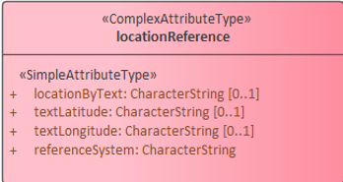

Figure 5-1 – locationReference – a complex attribute

## Units of Measure

The following units of measure are used in Polygonal Demarcations of Global Sea Areas datasets;

* Orientation is given in decimal degrees
* Uncertainty is given in metres
* Distances are given in metres or nautical miles

## Geometric Representation

Geometric representation is the digital description of the spatial component of an object as described in S-100 and ISO 19107. This product specification uses three types of geometries (GM_Point, GM_OrientableCurve, GM_OrientableSurface) and NoGeometry.

# Coordinate Reference System (CRS)

### Horizontal reference system

Spatial data are expressed in latitude and longitude geographic coordinates in reference to a horizontal reference system.

The longitude is stored as a negative number to represent a position west of the prime meridian (0°). Latitude is stored as a negative number to represent a position south of the equator.

Latitude and Longitude may also be stored as textual strings. This is required so that positions may be described in the exact format that they are described in the source document they were extracted from. If a position is described in a source document in degrees, minutes and seconds then this description must be retained in the textual string as degrees, minutes and seconds because a conversion to decimal degrees would constitute a change in format from its defined value. The same latitude and longitude position may also be stored as a set of real numbers within a GIS system so that it can be used digitally. That is, the values used in a source document must be preserved, but points and other geometric primitives may have multiple representations.

Different reference systems are used by various nations. Since data may come from different sources, multiple coordinate reference systems may be used in the same dataset.

### Projection

S-130 data products are unprojected.

### Temporal reference system

Time is measured by reference to Calendar dates and Clock time in accordance with ISO 19108:2002 Temporal Schema clause 5.4.4.

### Polygonal Demarcations of Global Sea Areas data and scale

S-130 data must be compiled in the best applicable scale. The use of the data itself is "scale independent". That means that the data can be used at any scale. S-100 allows the association of multiple spatial attributes to a single feature instance. In principle, each of these spatial attributes can be qualified by maximum and minimum scales.

For example, it is possible, within one dataset, to have a single instance of a feature that has more than one area geometry. Each of these geometries has different max/min scale attributes. Moreover, due to cluttering in smaller scales, the minimum scale attribute may be used to turn off portrayal of some features at smaller scales.

# Data quality

## Introduction to data quality

Data quality allows users and user systems to assess fitness for use of the provided data. Data quality measures and the associated evaluation are reported as metadata of a data product. This metadata improves interoperability with other data products and provides usage by user groups that the data product was not originally intended for. The secondary users can make assessments of the data product usefulness in their application based on the reported data quality measures.

For this edition of S-130, data quality reports are optional. If a data quality report is provided it must be separate from the exchange set (specifically, data quality reports are not treated as support files and are not included in the SUPPORT_FILES folder). The format of a data quality report is left to the producer or evaluator. The method of provision of data quality reports is also left to the producer or evaluator.

For S-130 the following Data Quality Elements have been included:

* Conformance to this Product Specification;
* Intended purpose of the data product;
* Completeness of the data product in terms of coverage;
* Logical Consistency;
* Positional Uncertainty and Accuracy;
* Thematic Accuracy;
* Temporal Quality;
* Aggregation measures;
* Validation checks or conformance checks including:
  + General tests for dataset integrity;
  + Specific tests for a specific data model.

## Completeness

The presence and absence of features is described by the data quality elements commission and omission. Completeness should only be used on the feature type level, describing whether the features in the universe of discourse are found in the data set or not.

### Commission

Commission is applicable for S-130.

S-130 products must be tested with Commission checks prior to release by the data producer. The data producer must review the check results and address any issues to ensure sufficient quality of the data products. It is allowable to publish the data with a quality statement which indicates non-conformance.

In terms of Commission, S-130 products must at least populate numberOfExcessItems that indicates the number of items that should not have been present in the dataset, and numberOfDuplicateFeatureInstances that indicates the total number of exact duplications of feature instances within the data.

### Omission

Omission is applicable for S-130.

S-130 products must be tested with Omission checks prior to release by the data producer. The data producer must review the check results and address any issues to ensure sufficient quality of the data products. It is allowable to publish the data with a quality statement which indicates non-conformance.

In terms of Omission, S-130 products must at least populate numberOfMissingItems that is the total number of missing items.

## Logical Consistency

### Conceptual Consistency

Conceptual Consistency is applicable for S-130 and follows the guidelines from S-100 Part 1.

S-130 products must be tested with Conceptual Consistency checks prior to release by the data producer. The data producer must review the check results and address any issues to ensure sufficient quality of the data products. Data should only be published if it passes the test.

In terms of Conceptual Consistency, S-130 products must at least populate numberOfInvalidSurfaceOverlaps that is the total number of erroneous overlaps within the data.

### Domain Consistency

Domain Consistency is applicable for S-130 and follows the guidelines from S-100 Part 5.

S-130 products must be tested with Domain Consistency checks prior to release by the data producer. The data producer must review the check results and address any issues to ensure sufficient quality of the data products. It is allowable to publish the data with a quality statement which indicates non-conformance.

In terms of Domain Consistency, S-130 products must at least populate numberOfNonconformantItems that is a count of all items in the dataset that are not in conformance with their value domain.

### Format Consistency

Format Consistency is applicable for S-130 and follows the guidelines from S-100 Part 10b.

S-130 products must be tested with Format Consistency checks prior to release by the data producer. The data producer must review the check results and address any issues to ensure sufficient quality of the data products. Data should only be published if it passes the test.

In terms of Format Consistency, S-130 products must at least populate physicalStructureConflicts that is a count of all items in the dataset that are stored in conflict with the physical structure of the dataset.

### Topological Consistency

Topological Consistency is applicable for S-130 and follows the guidelines from S-100 Part 7.

S-130 products must be tested with Topological Consistency checks prior to release by the data producer. The data producer must review the check results and address any issues to ensure sufficient quality of the data products. Data should only be published if it passes the test.

In terms of Topological Consistency, S-130 products must at least populate rateOfFaultyPointCurveConnections that is the number of faulty link-node connections in relation to the number of supposed link-node connections, numberOfMissingConnectionsUndershoots that is a count of items in the dataset within the parameter tolerance that are mismatched due to undershoots, numberOfMissingConnectionsOvershoots that is a count of items in the dataset within the parameter tolerance that are mismatched due to overshoots, numberOfInvalidSlivers that is a count of all items in the dataset that are invalid sliver surfaces, numberOfInvalidSelfIntersects that is a count of all items in the dataset that illegally intersect with themselves, and numberOfInvalidSelfOverlap that is all items in the dataset that illegally self-overlap.

## Positional Uncertainty and Accuracy

### Vertical Position Accuracy

Vertical Position Accuracy is not applicable for S-130.

### Horizontal Position Accuracy

Horizontal Position Accuracy is applicable for S-130 and follows the guidelines from S-100 Part 4c.

S-130 products must be tested with Horizontal Position Accuracy checks prior to release by the data producer. The data producer must review the check results and address any issues to ensure sufficient quality of the data products. It is allowable to publish the data with a quality statement which indicates non-conformance.

In terms of Horizontal Position Accuracy, S-130 products should populate circularError95 that indicates the radius describing a circle in which the true point location lies with the probability of 95%.

### Gridded Data Positional Accuracy

Gridded Data Position Accuracy is not applicable for S-130.

## Thematic Accuracy

### Thematic Classification Correctness

Thematic Classification Correctness is applicable for S-130 and follows the guidelines from S-100 Part 4c.

S-130 products must be tested with Thematic Classification Correctness checks prior to release by the data producer. The data producer must review the check results and address any issues to ensure sufficient quality of the data products. Data should only be published if it passes the test.

In terms of Thematic Classification Correctness, S-130 products must at least populate miscalculationRate that is the number of incorrectly classified features in relation to the number of features that are supposed to be there.

### Non-Quantitative Attribute Accuracy

Non-Quantitative Attribute Accuracy is applicable for S-130 and follows the guidelines from S-100 Part 4c.

S-130 products must be tested with Non-Quantitative Attribute Accuracy checks prior to release by the data producer. The data producer must review the check results and address any issues to ensure sufficient quality of the data products. It is allowable to publish the data with a quality statement which indicates non-conformance.

The accuracy of non-quantitative attributes can be correct or incorrect. S-130 products must at least populate numberOfIncorrectAttributeValues that is a count of all attribute values where the value is incorrect.

### Quantitative Attribute Accuracy

Quantitative Attribute Accuracy is not applicable for S-130 because there is no quantitative attribute in S-130.

## Temporal Quality

### Temporal Consistency

Temporal Consistency is not applicable for S-130.

### Temporal Validity

Temporal Validity is not applicable for S-130.

### Temporal Accuracy

Temporal Accuracy is not applicable for S-130.

## Aggregation

Aggregation is not applicable for S-130.

## Quality measure elements

The data quality measures recommended in S-97 (Part C) and their applicability in S-130 are indicated in Table 7-1 below. NA indicates the measure is not applicable. The application schema above has indicated how the data quality elements will be related to the data items, and the encoding description below will indicate how the quality elements will be encoded.

| **No.** | **Data quality element and sub element** | **Definition** | **DQ measure / description** | **Evaluation scope** | **Applicable to spatial representation types** |
| --- | --- | --- | --- | --- | --- |
| 1 | Completeness / Commission | Excess data present in a dataset, as described by the scope. | numberOfExcessItems / This data quality measure indicates the number of items in the dataset, that should not have been present in the dataset. | dataset/  dataset series | All features and info types |
| 2 | Completeness / Commission | Excess data present in a dataset, as described by the scope. | numberOfDuplicateFeatureInstances / This data quality measure indicates the total number of exact duplications of feature instances within the data. | dataset/  dataset series | All features and info types |
| 3 | Completeness / Omission | Data absent from the dataset, as described by the scope. | numberOfMissingItems / This data quality measure is an indicator that shows that a specific item is missing in the data. | dataset/  dataset series/  spatial object type | All features and info types |
| 4 | Logical Consistency / Conceptual Consistency | Adherence to the rules of a conceptual schema. | numberOfInvalidSurfaceOverlaps / This data quality measure is a count of the total number of erroneous overlaps within the data. Which surfaces may overlap and which must not is application dependent. Not all overlapping surfaces are necessarily erroneous. | spatial object / spatial object type | Features with surface geometry; spatial objects of type surface |
| 5 | Logical Consistency / Domain Consistency | Adherence of the values to the value domains. | numberOfNonconformantItems / This data quality measure is a count of all items in the dataset that are not in conformance with their value domain. | spatial object / spatial object type | All features and info types |
| 6 | Logical Consistency / Format Consistency | Degree to which data is stored in accordance with the physical structure of the data set, as described by the scope | physicalStructureConflicts / This data quality measure is a count of all items in the dataset that are stored in conflict with the physical structure of the dataset. | dataset/  dataset series | All features and info types |
| 7 | Logical Consistency / Topological Consistency | Correctness of the explicitly encoded topological characteristics of the dataset, as described by the scope. | rateOfFaultyPointCurveConnections / This data quality measure indicates the number of faulty link-node connections in relation to the number of supposed link-node connections. This data quality measure gives the erroneous point-curve connections in relation to the total number of point-curve connections. | spatial object / spatial object type | Features with curve geometry; spatial objects of curve types |
| 8 | Logical Consistency / Topological Consistency | Correctness of the explicitly encoded topological characteristics of the dataset, as described by the scope. | numberOfMissingConnectionsUndershoots / This data quality measure is a count of items in the dataset within the parameter tolerance that are mismatched due to undershoots. | spatial object / spatial object type | Features with curve geometry; spatial objects of curve types |
| 9 | Logical Consistency / Topological Consistency | Correctness of the explicitly encoded topological characteristics of the dataset, as described by the scope. | numberOfMissingConnectionsOvershoots / This data quality measure is a count of items in the dataset within the parameter tolerance that are mismatched due to overshoots. | spatial object / spatial object type | Features with curve geometry; spatial objects of curve types |
| 10 | Logical Consistency / Topological Consistency | Correctness of the explicitly encoded topological characteristics of the dataset, as described by the scope. | numberOfInvalidSlivers / This data quality measure is a count of all items in the dataset that are invalid sliver surfaces. A sliver is an unintended area that occurs when adjacent surfaces are not digitized properly. The borders of the adjacent surfaces may unintentionally gap or overlap to cause a topological error. | dataset / dataset series | Features with surface geometry; spatial objects of type surface |
| 11 | Logical Consistency / Topological Consistency | Correctness of the explicitly encoded topological characteristics of the dataset, as described by the scope. | numberOfInvalidSelfIntersects / This data quality measure is a count of all items in the dataset that illegally intersect with themselves. | spatial object / spatial object type | Features with surface geometry; spatial objects of type surface |
| 12 | Logical Consistency / Topological Consistency | Correctness of the explicitly encoded topological characteristics of the dataset, as described by the scope. | numberOfInvalidSelfOverlap / This data quality measure is a count of all items in the dataset that illegally self-overlap. | spatial object / spatial object type | Features with surface geometry; spatial objects of type surface |
| 13 | Positional Accuracy / Vertical Position Accuracy | Closeness of reported coordinative values to values accepted as or being true. | linearMapAccuracy2Sigma / Half length of the interval defined by an upper and lower limit in which the true value lies with probability 95%. | spatial object / spatial object type | NA. S-130 does not include vertical measure­ments. |
| 14 | Positional Accuracy / Horizontal Position Accuracy | Closeness of reported coordinative values to values accepted as or being true. | circularError95 / Radius describing a circle in which the true point location lies with the probability of 95%. | spatial object / spatial object type | Objects that have a horizontal coordinate values associated. |
| 15 | Positional Accuracy / Gridded Data Position Accuracy | Closeness of reported coordinative values to values accepted as or being true. | RMSerrorofplanimetry / Radius of a circle around the given point, in which the true value lies with probability P. | spatial object / spatial object type | NA. |
| 16 | Temporal Quality / Temporal Consistency | Correctness of ordered events or sequences, if reported. | chronologicalOrder/ This data quality measure that indicate that an event is incorrectly ordered against the other events. [Adapted from ISO 19157] | dataset/  dataset series/  spatial object type | NA. |
| 17 | Thematic Accuracy / ThematicClassificationCorrectness | Comparison of the classes assigned to features or their attributes to a universe of discourse. | miscalculationRate / This data quality measure indicates the number of incorrectly classified features in relation to the number of features that are supposed to be there. [Adapted from ISO 19157]  This is a RATE which is a ratio, and is expressed as a REAL number representing the rational fraction corresponding to the numerator and denominator of the ratio.  For example, if there are 1 items that are classified incorrectly and there are 100 of the items in the dataset then the ratio is 1/100 and the reported rate = 0.01. | dataset/  dataset series/  spatial object type | All features and info types |
| 18 | Thematic Accuracy / Non-Quantitative Attribute Accuracy | Correctness of non-quantitative attribute. | numberOfIncorrectAttributeValues / This data quality measure is count of the total number of erroneous attribute values within the relevant part of the dataset. It is a count of all attribute values where the value is incorrect. [Adapted from ISO 19157] | dataset/  dataset series/  spatial object type | All features and info types |
| 19 | Thematic Accuracy / Quantitative Attribute Accuracy | Accuracy of a quantitative attribute. | attributeValueUncertainty3Sigma / This data quality measure indicates the attribute value of uncertainty where half the length of the interval defined by an upper and lower limit in which the true value for the quantitative attribute lies with a probability of 95%. [Adapted from ISO 19157] | dataset/  dataset series/  spatial object type | NA |
| 20 | Aggregation Measures / AggregationMeasures | In a data product specification, several requirements are set up for a product to conform to the specification. | DataProductSpecificationPassed / This data quality measure is a boolean indicating that all requirements in the referred data product specification are fulfilled. | dataset/  dataset series/  spatial object type | NA |
| 21 | Aggregation Measures / AggregationMeasures | In a data product specification, several requirements are set up for a product to conform to the specification. | DataProductSpecificationFailRate / This data quality measure is a number indicating the number of data product specification requirements that are not fulfilled by the current product/dataset in relation to the total number of data product specification requirements. | dataset/  dataset series/  spatial object type | NA |

Table 7-1 - IHO recommended quality elements and their relevance to S-130

# Data Capture and Classification

The production process used to generate S-130 products may be described in the dataset metadata. Since S-100 Edition 5.2.0 discovery metadata does not provide distinct classes or fields for describing the production process, the descriptions may be combined into a text string in the *comment* field of S100_DatasetDiscoveryMetadata (clause 12.2.4).

|  |  |  |  |
| --- | --- | --- | --- |
| **Item Name** | **Description** | **Multiplicity** | **Type** |
| dataSource | Identification of the kinds of data sources usable to product datasets compliant with S-130 | 0..* | CharacterString |
| productionProcess | Link to a textual description of the production process (including encoding guide) applicable to the datasets compliant with S-130 | 0..* | CharacterString (URL) |

Table 8-1 - Data capture information

## Data Encoding and Product Delivery

### Data Encoding

The principal encoding will be the S-100 profile of the Open Geospatial Consortium (OGC), Geography Markup Language (GML) format. GML is an XML grammar designed to express geographical features. It serves as a modelling language for geographic systems as well as an open interchange format for geographic transactions. The GML encoding is in conformance with S-100 Part 10b.

### Types of Datasets

A dataset is a grouping of features, attributes, geometry and metadata which comprises a specific coverage. The following types of S-130 dataset may be produced and contained within an exchange set:

|  |  |
| --- | --- |
| **Dataset** | **Explanations** |
| New dataset (base dataset): | Data for an area different (in coverage and/or extent) to existing datasets. |
| New Edition of a dataset: | A re-issue plus new information which has not been previously distributed by Updates. Each New Edition of a dataset must have the same name as the dataset that it replaces and should have the same spatial extents. The edition number in the dataset discovery metadata must increment up by one from the previous edition. |
| Update | Changing some information in an existing dataset |
| Reissue | A complete dataset including all the updates applied to the original dataset up to the date of the re-issue. |
| Cancellation | Used to cancel dataset. |

Table 8-2 - S-130 dataset types

### Data Format for Update Datasets

Update datasets use the same data format as base datasets.

S-130 uses the “whole-object update” approach described in S-100 clause 10b-11.5 and elaborated below.

* Updates are only defined at a feature or information type level. Individual attribute values cannot be updated without updating the feature or information type instance as a whole.
* Updates can only add new instances or replace existing instances of feature or information types.
* Updated feature or information type instances must retain the GML identifier for their predecessor instances in the base dataset.
* Feature or information type instances in an update dataset must include all attributes and associations for the original instance, since the whole data object is being replaced.
* It is not possible to update associations except by replacing all feature or information type instances affected by a change to references.
* If an update to a feature or information type involves no change to its associations, either to the original feature, or from the original to another feature or information type, it is not necessary to include the associated instances in the update dataset (unless they are also being updated).
* It is not possible to delete feature or information type instances through an update. A new edition of the dataset must be issued to delete an instance without replacement.

### Data Format for Cancellation Datasets

Cancellation datasets use the same data format as base datasets but include no spatial objects or instances of feature or information types.

## Numeric Attribute Encoding

Floating point and integer attribute values must not contain leading zeros. Floating point attribute values must not contain non-significant trailing zeros.

## Text Attribute Values

Character strings must be encoded using the character set defined in ISO 10646-1, in Unicode Transformation Format-8 (UTF-8).

## Mandatory Attribute Values

All mandatory attributes are identified in the Feature Catalogue and summarised in Annex A – Data Classification and Encoding Guide.

## Unknown Attribute Values

When a mandatory attribute code or tag is present but the attribute value is missing, it means that the producer wishes to indicate that this attribute value is unknown. Missing mandatory attributes must be “nilled”.

Optional attributes must be omitted altogether if the value is unknown or missing. They must not be “nilled.”

EXAMPLE An instance of **SourceInformation** has unknown sourceType (mandatory attribute). The instance could be coded as:

<SourceInformation>

<sourceIndication>

<source>...</source>

<sourceType xsi:nil=”true”/>

</sourceIndication>

</SourceInformation>

## Structure of dataset files

### Sequence of objects

The order of data objects in each dataset file is described below:

Dataset Identification Information

Dataset structure information

Spatial records for by-reference geometries

Point

Curve

Composite Curve

Surface

Information objects

Feature objects (Geometry may be encoded inline or by reference.)

Meta features

Geo features

## Object identifiers

A unique worldwide identifier of feature records is provided through a feature attribute (featureIdentifier).

The numeric component of featureIdentifier attributes must be encoded as:

YYYYYYXXXXXX

where:

* YYYYYY: number computed by adding an offset of 90.000 to the latitude coordinate of the centroid in decimal degrees (3 decimals);
* XXXXXX: number computed by adding 180.000 to the longitude coordinate of the centroid in decimal degrees (3 decimals);
* leading and trailing zeros are used as necessary so that each number computed as above is exactly 6 digits.

EXAMPLE: A feature with a centroid of 50.0° N 40.0° W (latitude=+50.0, longitude=-40.0 in decimal degrees) will have numeric identifier component 140000140000

Features, information types, collection objects, meta features, and geometries (inline or external) are all required by the schema to have a **gml:id** attribute with a value that is unique within the dataset. The **gml:id** values must be used as the reference for the object from another object in the same dataset or another dataset.

## Data coverage

All areas of a dataset must be covered by a **DataCoverage** meta feature.

An update dataset must not change the limit of a **DataCoverage** feature for the base dataset. Where the limit of a **DataCoverage** feature for a base dataset is to be changed, this must be done by issuing a new edition of the dataset.

## Data overlap

S-130 datasets may overlap other S-130 datasets.

# Data Delivery

## Data Product Delivery Information

This data product specification defines GML as the primary format in which S-130 data products are delivered. The delivery format is described by the following items (from ISO 19131:2005): format name, version, specification description, language, character set.

|  |  |  |
| --- | --- | --- |
| **Name** | **ISO 19131 Elements** | **Value** |
| Format name | DPS_DeliveryInformation.deliveryFormat > DPS_DeliveryFormat.formatName | GML* |
| Version | DPS_DeliveryInformation.deliveryFormat > DPS_DeliveryFormat.version | 3.2.1 |
| Specification description | DPS_DeliveryInformation.deliveryFormat > DPS_DeliveryFormat.specification | GML* |
| Language | DPS_DeliveryInformation.deliveryFormat > DPS_DeliveryFormat.language | English |
| Character set | DPS_DeliveryInformation.deliveryFormat > DPS_DeliveryFormat.characterSet > MD_CharacterSetCode | 004 – utf8 |

Table 9-1 - Data product delivery

* GML is an XML encoding for the transport and storage of geographic information, including both the geometry and the properties of geographic features, between distributed systems. The XML Schema for the GML application schema is provided in a schema document S130.xsd which imports other schema(s) defining common types. Feature instances must validate against S130.xsd and conform to all other requirements specified in this data product specification including all constraints not captured in the XML Schema document.

### New editions

When a new edition of a dataset is received, the system must replace the previous edition, along with its updates, with the new edition of the dataset.

## Exchange Set

Data which conforms to this product specification must be delivered by means of an exchange set.

### Components of the exchange set

An exchange set will consist of one or more S-130 datasets. Each exchange set will include a single (XML) exchange catalogue file containing discovery metadata for each S-130 dataset. S-130 exchange set catalogues conform to S-100 5.2.0 Part 17, clause 17-4.5.

S-130 Exchange set structure conforms to S-100 5.2.0 Part 17, clause 17-2. Since S-130 exchange sets do not contain ISO metadata files, the corresponding components are omitted from Figure 9-1 below.

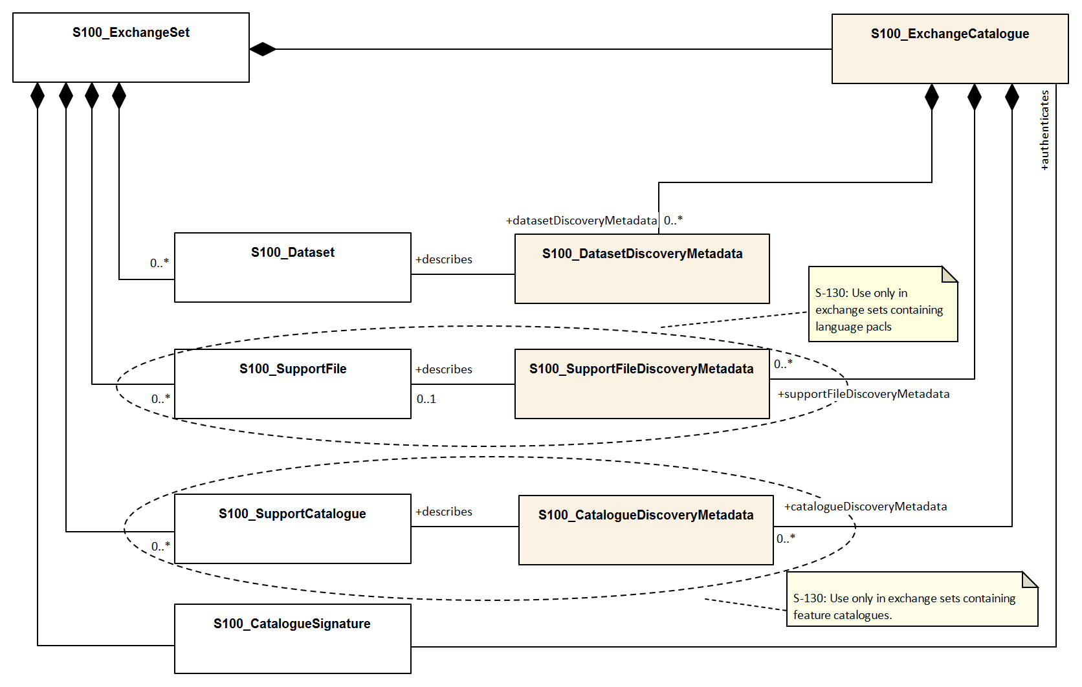

Figure 9-1 - S-130 Exchange set components

### Exchange set structure

Data products are delivered as packages (such as ZIP archives or files organised within a file system folder/directory structure) containing both the Exchange Catalogue and one or more datasets, updates or language packs.

The structure of an S-130 Exchange Set must be according to the structure described below, which is based on S-100 Part 17, clause 17-4.2. The S-130 Exchange Set structure is depicted in Figure 9-2.

1. All content must be placed inside a top root folder named S100_ROOT. This is the only top level root folder in an Exchange Set containing only S-100 products.
2. The S100_ROOT folder must contain a subfolder for S-130 which holds content specific to S-130, an Exchange Set Catalogue, CATALOG.XML, and its digital signature CATALOG.SIGN.
3. The S-130 subfolder must contain subfolders for the component dataset files (DATASET_FILES) and Catalogues (CATALOGUES) as required:
   1. The DATASET_FILES subfolder is required if and only if the Exchange Set contains an S-130 dataset (base or update).
   2. The CATALOGUES subfolder is required if and only if the Exchange Set contains a Feature Catalogue. (This Edition of S-130 does not include Interoperability or Portrayal Catalogues.)
4. The DATASET_FILES folder must contain a subfolder named according to the Producer Code.
5. Individual data files must be placed under the Producer subfolder, either directly in the Producer folder, or within a lower-level subfolder hierarchy. Individual data files may be optionally placed in their own subfolders or grouped with other data files.
6. An Exchange Set may carry a Feature Catalogue, which should also be placed in the CATALOGUES folder.
7. An exchange set may include zero, one, or more language packs. If included, language packs must be placed in the SUPPORT_FILES folder.
8. Except for the signature of the Exchange Catalogue file (CATALOG.XML), which is in the CATALOG.SIGN file, all digital signatures are included within their corresponding resource metadata records in CATALOG.XML.
9. Dataset and Catalogue file and/or folder names should be such as to avoid inadvertent overwriting of files.
10. Digital signatures are required for Exchange Sets and datasets conforming to S-100 Edition 5.2.0. All resources included within an Exchange Set, including support files and catalogues, must be signed (S-100 Part 17).

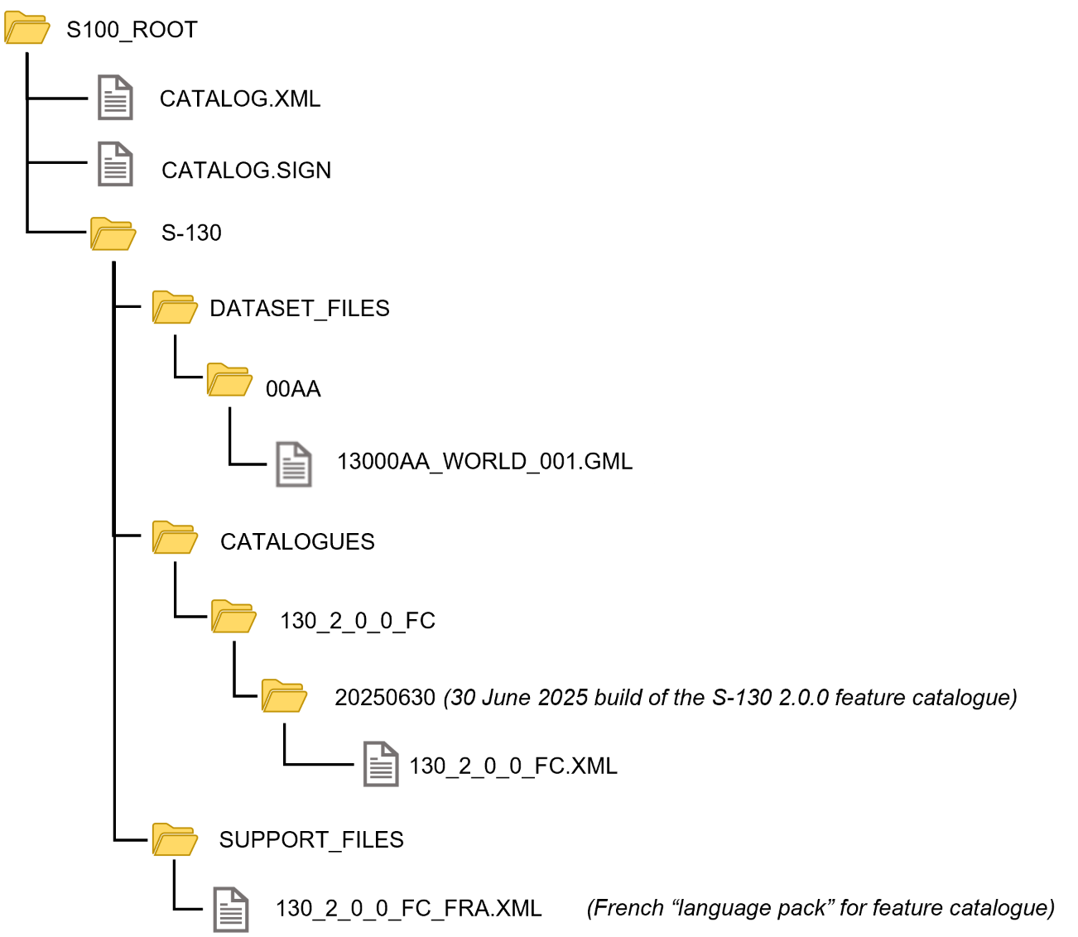

Figure 9-2 - Typical S-130 Exchange Set structure

General guidelines for Exchange Set structure are provided in S-100 Part 17.

Note that the names and locations of files are coded within the CATALOG.XML files, and therefore files and folders should not be renamed or relocated by Producers or end-user systems unless these references can be updated. Feature Catalogues can be relocated to a common system location if their internal structure is maintained.

## Dataset Naming Convention

All dataset files must have unique world-wide file identifiers. The file identifier of the dataset should not be used to describe the physical content of the file. The dataset file metadata that accompanies the file will inform the user of the name and purpose of the file (new, replacement and deletion).

In this encoding the dataset files are named according to the specifications given below:

130CCCCØØØØØØØØØØ.GML

The main part forms an identifier where:

* 130 - the first 3 characters identify the dataset as an S-130 dataset (mandatory).
* CCCC - the fourth to seventh characters identify the producer code of the issuing agency. Where the producer code is derived from a 2 or 3 character format, the missing characters of the producer code must be populated with zeros (“00” or “0” respectively) for the sixth and seventh characters of the dataset file name, as required.
* ØØØØØØØØØØ - the eighth to the maximum seventeenth characters are optional and may be used in any way by the producer to provide the unique file name. The following characters are allowed in the dataset name: A to Z, 0 to 9 and the special character _ (underscore).
* .GML – new datasets and new editions.

Update datasets must have the same base name as the base dataset with a suffix of the form “_NNN” corresponding to the update number:

130CCCCØØØØØØØØØØ_NNN.GML where NNN is 001, 002, etc.

The maximum length of an update file is therefore 4 characters greater than for base datasets.

## Support File Naming Convention

Support file names are subject to the same naming rules as dataset file names (clause 9.3), except that the extension is determined by the support file format (XML for language packs) and the length is determined by the name of the Feature Catalogue file.

This clause covers names of language packs, which are the only support files allowed in this Edition of S-130.

If a language pack created by a Data Producer for the S-130 Feature Catalogue is included, it must have the standard 7-character “130CCCC” prefix and the same base name as the standard IHO-issued Feature Catalogue with the 3-letter ISO 639-2/T language code suffixed. The language codes must be exactly those in the S-100 codelist for languages (S100_MD_LanguageCode, which can be found in the S-100 Schema distribution). The file extension must be “.XML”.

NOTE: A language pack issued by the IHO for the IHO Feature Catalogue will use the IHO Producer Code.

EXAMPLE: The language pack for Italian translations issued by the Data Producer with code “IT01” of the Feature Catalogue named 130_1_1_0_FC.XML is named 130IT01_130_1_1_0_FC_ita.XML.

# Data Maintenance

## Introduction

Datasets are maintained as needed and must include mechanisms for S-130 updating. Data updates will be made by new editions. The maintenance and update frequency of S-130 datasets should be defined by the producers implementing this specification.

Data Producers must use applicable sources to maintain and update data and provide a brief description of the sources that were used to produce the dataset in the appropriate metadata field.

The data product must provide information on how the data is maintained and should describe the principles and criteria applied in maintenance regime. This should specify the expected frequency of updates.

|  |  |  |  |
| --- | --- | --- | --- |
| **Item Name** | **Description** | **Multiplicity** | **Type** |
| maintenanceAndUpdateFrequency | Frequency with which changes and additions are made to the data product (per update scope) | 1..* | MD_MaintenanceInformation (ISO 19115) |
| dataSource | Identification of the kinds of data sources usable to produce datasets | 1..* | LI_Source (ISO 19115) |
| productionProcess | Textual description of the production process applicable to the datasets (per scope or data source) | 1..* | LI_ProcessStep (ISO 19115) |

Table 10-1 - Maintenance and update frequency

Since S-100 Edition 5.2.0 Part 17 does not provide distinct metadata fields for data source and production process, summarized information about these may be included in the *comment* field in S100_DatasetDiscoveryMetadata (clause 12.2.4).

## Production process for base and update datasets

Data Producers should follow their established production processes for maintaining and updating datasets. Data is produced against the DCEG and checked against S-158:130 Polygonal Demarcations of Global Sea Areas Data Product Validation Checks.

## Dataset updates and cancellation

The purpose of issue of the dataset is indicated in the “purpose” field of the dataset discovery metadata. In order to terminate a dataset, an update dataset file is created for which the edition number must be set to 0. This convention is only used to cancel a base dataset file.

Where a dataset is cancelled and its name is reused at a later date, the issue date must be greater than the issue date of the cancelled dataset.

When the dataset is cancelled it must be removed from the system.

An exchange set may contain base dataset files and update dataset files for the same datasets. Under these circumstances the update dataset files must follow in the correct sequential order from the last update applied to the base dataset file.

## Support file updates

The purpose of issue is indicated in the “purpose” field of the support file discovery metadata. Support files carrying the “deletion” flag in metadata must be removed from the system. When a feature or information type pointing to a text, picture or application file is deleted or updated so that it no longer references the file, the system software must check to see whether any other feature or information type references the same file, before that file is deleted.

## Feature catalogues

For each new version of the S-130 Product Specification a new feature catalogue will be released. The system must be able to manage datasets and their catalogues that are created on different versions of the S-130 Product Specification.

## Feature history, versions and change tracking

If applications or production systems require versioning of individual instances of feature or information types, maintenance of histories, or change tracking, the methods for versioning, history management, and change tracking and display are left to the application or production system.

# Portrayal

No specific portrayal implementation is included within this Product Specification.

# Metadata

## Introduction

S-100 provides for supplying the following categories of metadata with S-100 based Exchange Sets:

* Metadata about the overall Exchange Set and the Exchange Catalogue;
* Discovery metadata about each of the datasets contained in the Exchange Set; and
* Discovery metadata about the support files that make up the package;
* Metadata about any Feature, Portrayal, or Interoperability Catalogues included in the Exchange Set.

In an S-100 Exchange Set, the above metadata is provided by the Exchange Catalogue, which is an XML file containing XML blocks describing discovery metadata for the exchange set and its components.

The discovery metadata classes described in S-100 Part 17 have numerous attributes which enable important information about the datasets and accompanying support files to be examined without the need to process the data, for example, decrypt, decompress, load, etc. S-100 Figure 17-2 depicts the conceptual structure of an S-100 Exchange Set and the relationships between components of the Exchange Set and discovery metadata in the Exchange Catalogue. The Exchange Catalogue is structured as depicted in S-100 Figures 17‑6 and 17-7. Detailed specifications for metadata are provided in S-100 clause 17-4.5.

This edition of S-130 implements the metadata structure and encoding defined in S-100 Edition 5.2.0 Part 17. This Edition of S-130 does not include a Portrayal Catalogue, does not use ISO metadata files, and does not provide for S-130 datasets to reference support files. The optional discovery metadata which S-100 Part 17 provides for portrayal catalogues and ISO metadata files are therefore not permitted for S-130 data.

Clause 12.2 provides details about the mandatory and optional metadata for S-130.

## Elements of S-130 Exchange Catalogues

S-130 metadata in Exchange Catalogues is derived from S-100 Part 17, Figure 17-7, with the following restrictions:

* S-130 does not use certain optional elements and fields defined in S-100 generic metadata. Elements that are optional in the generic S-100 catalogue model but not used in S-130 are not shown.
* S-130 makes certain optional S-100 elements or fields mandatory. Elements that are optional in S-100 but mandatory in S-130 are shown with the restricted multiplicity in place of that given in S-100 Part 17 (for example, as “1” instead of the generic “0..1”) and the restriction is noted in the Remarks column.
* S-130 imposes certain product-specific requirements on the values of some metadata fields. These requirements are described in the Remarks column.

In S-130 Edition 2.0.0 the only catalogues defined for S-130 products are Feature Catalogues.

The default language used by the Exchange Catalogue may be specified in the *defaultLocale* field of **S100_ExchangeCatalogue** (clause 0). If omitted, the default language is English. See S-100 Part 17, clauses 17-4.6 – 17-4.8 for guidance on encoding of metadata in languages other than English.

The following clauses define the mandatory and optional metadata used by S-130. Differences from generic S-100 metadata are emphasized for developer convenience in bold text in the documentation tables, and comments noting the difference are included in the Remarks column. Where S-130 does not impose any restrictions on the S-100 class, the corresponding documentation table has been omitted from this document.

Figure 12-1 below depicts the detailed structure of the S-130 Exchange Catalogue. This Figure is derived from S-100 Part 17, Figure 17-7, modified to omit elements (classes, attributes, and enumeration values) that are optional in the generic S-100 catalogue model and not used in S-130.

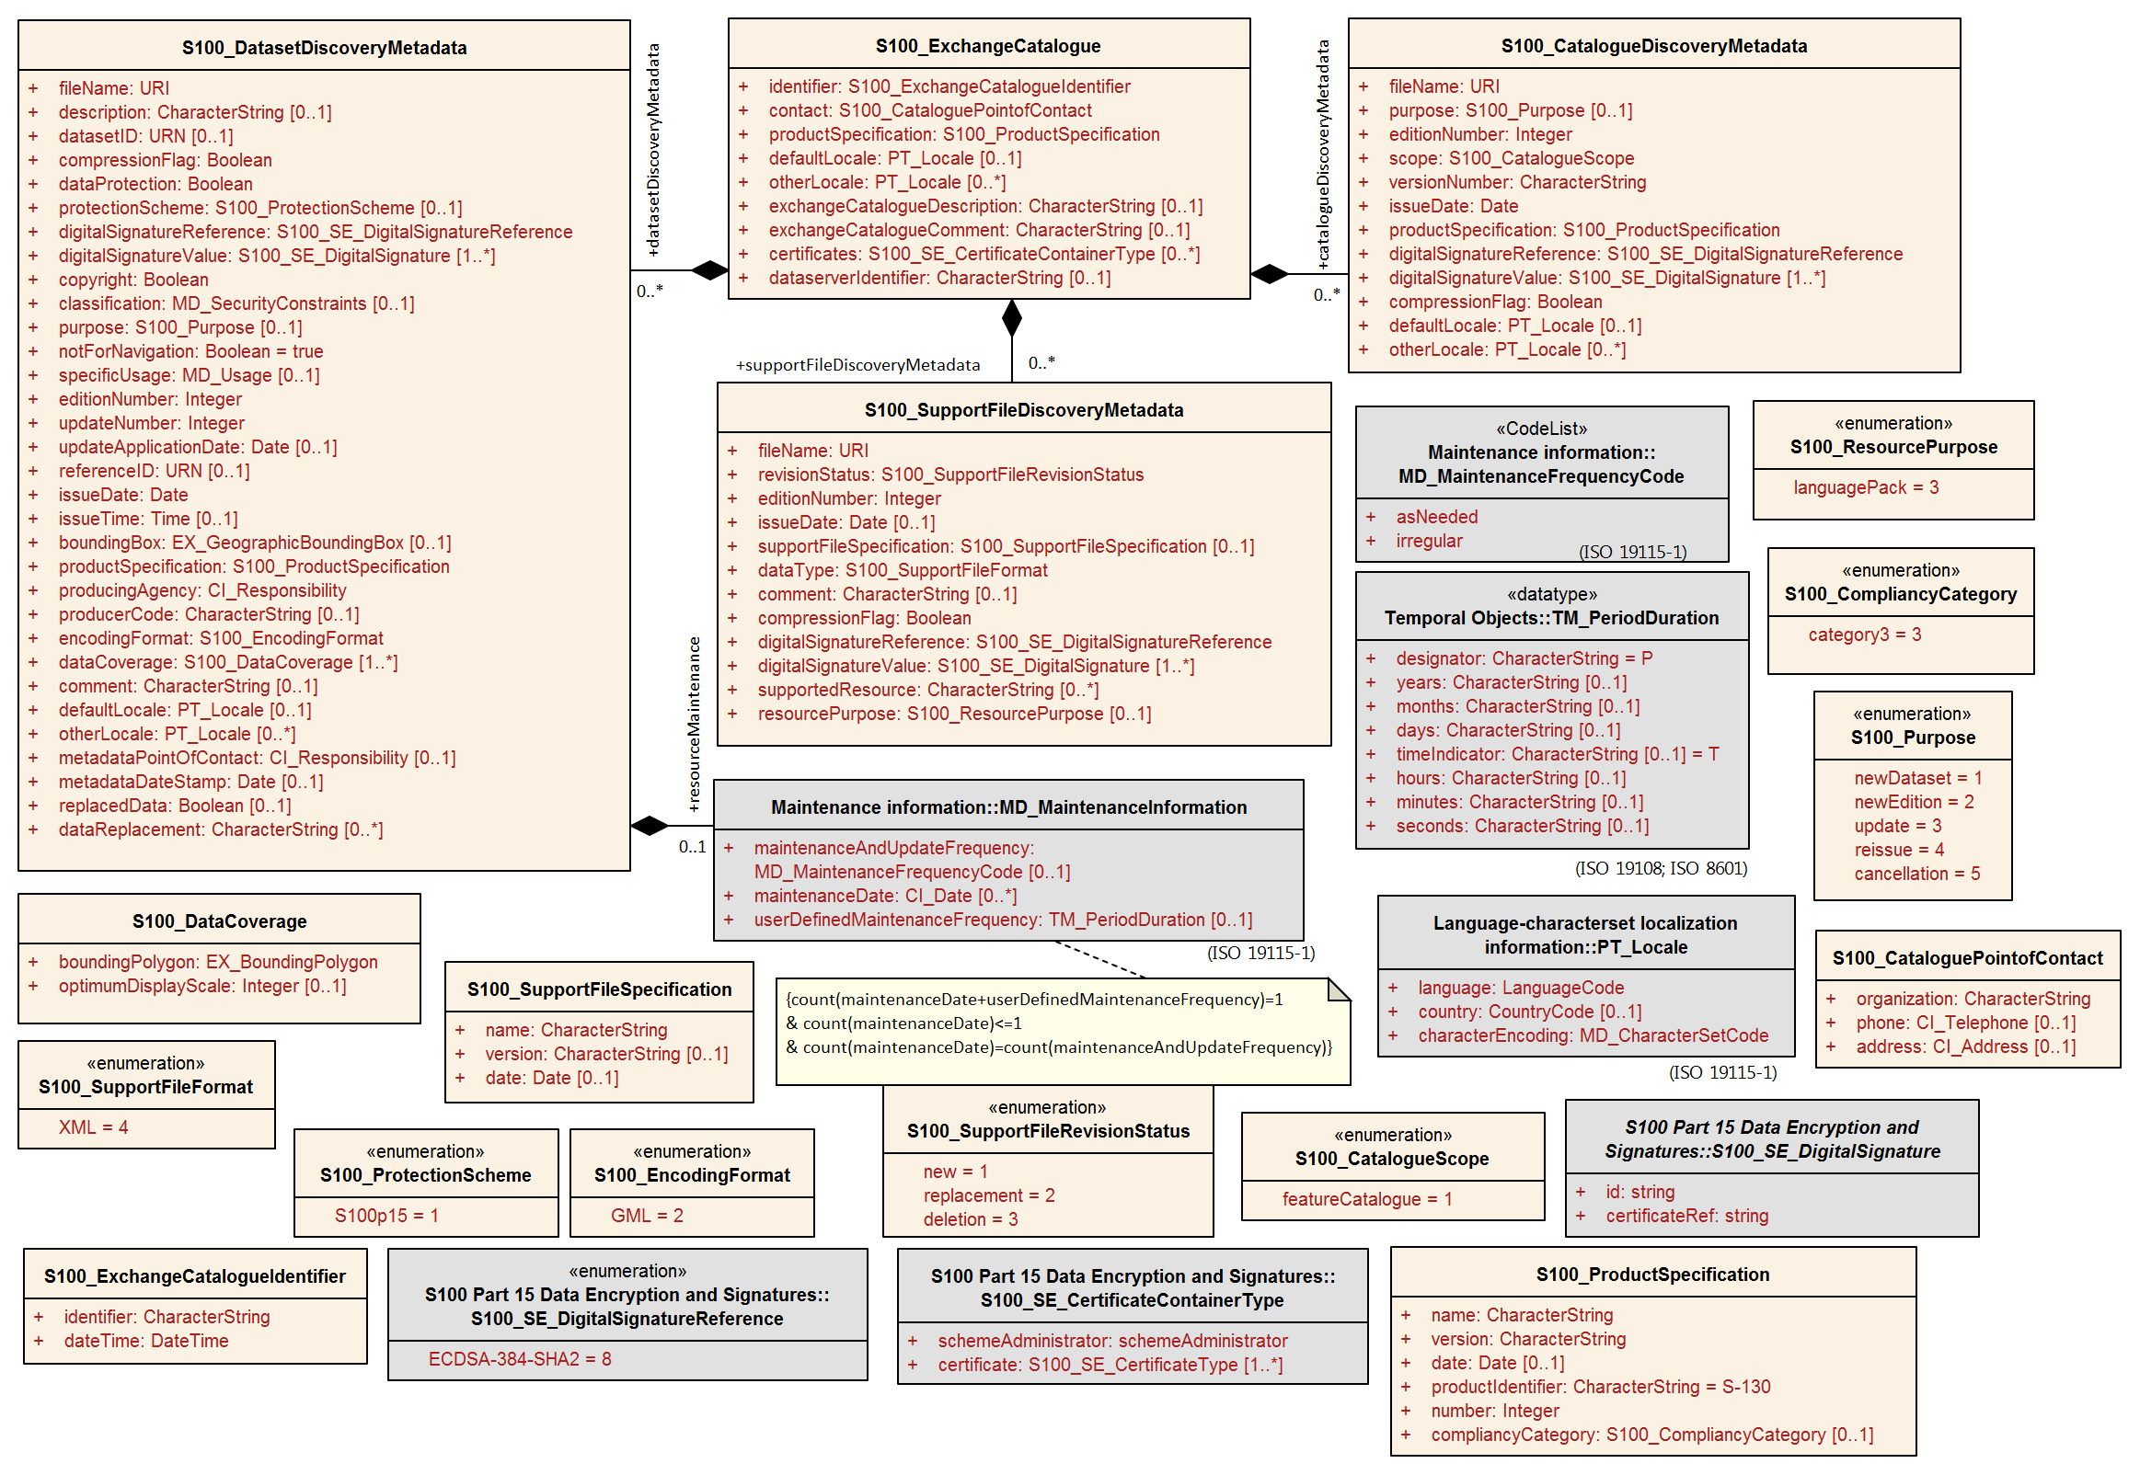

Figure 12-1 - Exchange Catalogue class details

### S100_ExchangeCatalogue

The S-130 Exchange Catalogue metadata conforms to S-100 Part 17 with additional S-130-specific restrictions.

|  |  |  |  |  |
| --- | --- | --- | --- | --- |
| **Name** | **Description** | **Mult** | **Type** | **Remarks** |
| S100_ExchangeCatalogue | An Exchange Catalogue contains the discovery metadata about the exchange datasets and support files | - |  | - |
| identifier | Uniquely identifies this Exchange Catalogue | **1** | S100_ExchangeCatalogueIdentifier | 0..1 multiplicity in S-100 restricted to 1 in S-130 |
| contact | Details about the issuer of this Exchange Catalogue | **1** | S100_CataloguePointOfContact | 0..1 multiplicity in S-100 restricted to 1 in S-130 |
| productSpecification | Details about the Product Specifications used for the datasets contained in the Exchange Catalogue | **1**,.* | S100_ProductSpecification | The Exchange Catalogue may contain datasets from Product Specifications other than S-130  0..* multiplicity in S-100 restricted to 1..* in S-130 |
| defaultLocale | Default language and character set used for all metadata records in this Exchange Catalogue | 0..1 | PT_Locale | Default is English and UTF-8. |
| otherLocale | Other languages and character sets used for the localized metadata records in this Exchange Catalogue | 0..* | PT_Locale | Required if any localized entries are present in the Exchange Catalogue |
| exchangeCatalogueDescription | Description of what the Exchange Catalogue contains | 0..1 | CharacterString |  |
| exchangeCatalogueComment | Any additional Information | 0..1 | CharacterString |  |
| certificates | Signed public key certificates referred to by digital signatures in the Exchange Set | 0..* | S100_SE_CertificateContainerType | Content defined in S-100 Part 15. All certificates used, except the SA root certificate (installed separately by the implementing system) shall be included |
| dataServerIdentifier | Identifies the data server for the permit | 0..1 | CharacterString |  |
| datasetDiscoveryMetadata | Exchange Catalogues may include or reference discovery metadata for the datasets in the Exchange Set | 0..* | Aggregation S100_DatasetDiscoveryMetadata |  |
| catalogueDiscoveryMetadata | Metadata for Catalogue | 0..* | Aggregation S100_CatalogueDiscoveryMetadata | Metadata for the Feature Catalogue, if included in the Exchange Set. Portrayal and Interoperability Catalogues are not defined for S-130. |
| supportFileDiscoveryMetadata | Exchange Catalogues may include or reference discovery metadata for the support files in the Exchange Set | 0..* | Aggregation S100_SupportFileDiscoveryMetadata |  |

### S100_ExchangeCatalogueIdentifier

S-130 uses S100_ExchangeCatalogueIdentifier without modification.

### S100_CataloguePointofContact

S-130 uses S100_CataloguePointOfContact without modification.

### S100_DatasetDiscoveryMetadata

S-130 restricts the multiplicity and contents of S100_DatasetDiscoveryMetadata as described in the Remarks column in the table below.

Dataset discovery metadata for an update dataset also uses S100_DatasetDiscoveryMetadata. Update dataset metadata is intended to describe information about an update dataset. It facilitates the management and exploitation of data and is an important requirement for understanding the characteristics of an update dataset. Whereas dataset metadata is usually fairly comprehensive, metadata for update datasets only describe the issue date and sequential relation to the base dataset. Optional fields may therefore be omitted for update metadata unless mandated in the Remarks column.

| **Name** | **Description** | **Mult** | **Type** | **Remarks** |
| --- | --- | --- | --- | --- |
| S100_DatasetDiscoveryMetadata | Metadata about the individual datasets in the Exchange Catalogue | - | - | **The optional S-100 attributes *navigationPurpose, temporalExtent* and *approximateGridResolution* are prohibited in S-130.**  **The optional S-100 attributes *dataCoverage* and *editionNumber* are mandatory in S-130** |
| fileName | Dataset file name | 1 | URI | See S-100 Part 1, clause 1-4.6 |
| description | Short description giving the area or location covered by the dataset | 0..1 | CharacterString | For example a harbour or port name, between two named locations etc.  For an update dataset this field should contain a brief description of the update. |
| datasetID | Dataset ID expressed as a Maritime Resource Name | 0..1 | URN | The URN must be an MRN |
| compressionFlag | Indicates if the resource is compressed | 1 | Boolean | *true* indicates a compressed dataset resource  *false* indicates an uncompressed dataset resource |
| dataProtection | Indicates if the data is encrypted | 1 | Boolean | *true* indicates an encrypted dataset resource  *false* indicates an unencrypted dataset resources |
| protectionScheme | Specification of method used for data protection | 0..1 | S100_ProtectionScheme | In S-100 the only allowed value is “S100p15” |
| digitalSignatureReference | Specifies the algorithm used to compute digitalSignatureValue | 1 | S100_SE_DigitalSignatureReference (see S-100 Part 15) | Signatures are mandatory in S-100 Edition 5.2.0 |
| digitalSignatureValue | Value derived from the digital signature | 1..* | S100_SE_DigitalSignature (see S-100 Part 15) | The value resulting from application of *digitalSignatureReference*  Implemented as the digital signature format specified in Part 15  **At least one S100_SE_SignatureOnData is required** |
| copyright | Indicates if the dataset is copyrighted | 1 | Boolean | *true* indicates the resource is copyrighted  *false* Indicates the resource is not copyrighted  For an update dataset the value must be the same as the base dataset |
| classification | Indicates the security classification of the dataset | 0..1 | MD_SecurityConstraints> MD_ClassificationCode (codelist) | 1. unclassified  2. restricted  3. confidential  4. secret  5. top secret  6. sensitive but unclassified  7. for official use only  8. protected  9. limited distribution  For an update dataset the value must be the same as the base dataset |
| purpose | The purpose for which the dataset has been issued | 0..1 | S100_Purpose |  |
| notForNavigation | Indicates the dataset is not intended to be used for navigation | 1 | Boolean | *true* indicates the dataset is not intended to be used for navigation  *false* indicates the dataset is intended to be used for navigation  **S-130 permits only the value *true*.** |
| specificUsage | The use for which the dataset is intended | 0..1 | MD_USAGE>specificUsage (character string) | Information about specific usage(s) for which the dataset is intended |
| editionNumber | The Edition number of the dataset | **1** | Integer | **Mandatory in S-130**  **For an update dataset the value must be the same as the base dataset** |
| updateNumber | Update number assigned to the dataset and increased by one for each subsequent update | **1** | Integer | Update number 0 is assigned to a new dataset  **Mandatory in S-130**  **For an update dataset the update sequence number, must match file name** |
| updateApplicationDate | This date is only used for the base cell files (that is new data set, re-issue and new edition), not update cell files. All updates dated on or before this date must have been applied by the producer | 0..1 | Date |  |
| referenceID | Reference back to the datasetID | 0..1 | URN | In update metadata refers to the datasetID of the dataset metadata. This is used if and only if the dataset is an update  The URN must be an MRN |
| issueDate | Date on which the data was made available by the Data Producer | 1 | Date | **The date on which the dataset was generated.**  **For an update dataset, this must be on or after the issue date of the base dataset and the most recent previous update** |
| issueTime | Time of day at which the data was made available by the Data Producer | 0..1 | Time |  |
| boundingBox | The extent of the dataset limits | 0..1 | EX_GeographicBoundingBox | **Not used for update datasets.** |
| productSpecification | The product specification used to create this dataset | 1 | S100_ProductSpecification |  |
| producingAgency | Agency responsible for producing the data | 1 | CI_ResponsibleParty>CI_Organisation | See S-100 Part 17 |
| producerCode | The official IHO Producer Code from S‑62 | 0..1 | CharacterString | **Recommended for S-130 datasets** |
| encodingFormat | The encoding format of the dataset | 1 | S100_EncodingFormat | **Must be GML** |
| dataCoverage | Area covered by the dataset | **1**..* | S100_DataCoverage | **Mandatory in S-130**  **For an update, must be the same as the base dataset.** |
| comment | Any additional information | 0..1 | CharacterString |  |
| defaultLocale | Default language and character set used in the dataset | 0..1 | PT_Locale | If omitted the language must be English, UTF-8 |
| otherLocale | Other languages and character sets used in the dataset | 0..* | PT_Locale |  |
| metadataPointOfContact | Point of contact for metadata | 0..1 | CI_Responsibility > CI_Individual or CI_Responsibility > CI_Organisation | Only if metadataPointOfContact is different from producingAgency |
| metadataDateStamp | Date stamp for metadata | 0..1 | Date | May or may not be the issue date |
| replacedData | Indicates if a cancelled dataset is replaced by another data file(s) | 0..1 | Boolean | **Mandatory when *purpose* = *cancellation*** |
| dataReplacement | Dataset name | 0..* | CharacterString | A dataset may be replaced by 1 or more datasets  **Mandatory when *replacedData* = *true*** |
| resourceMaintenance | Information about the frequency of resource updates, and the scope of those updates | 0..1 | MD_MaintenanceInformation | S-100 restricts the multiplicity to 0..1 and adds specific restrictions on the ISO 19115 structure and content. See clause **MD_MaintenanceInformation** in S-100 Part 17  Format: PnYnMnDTnHnMnS (XML built-in type for ISO 8601 duration). See S-100 Part 17, clause 17-4.9 for encoding guidance |

#### S100_NavigationPurpose

The enumeration S100_NavigationPurpose is not used in S-130.

#### S100_DataCoverage

S-130 uses S100_DataCoverage with the restrictions specified in the following table.

|  |  |  |  |  |
| --- | --- | --- | --- | --- |
| **Name** | **Mult** | **Value** | **Type** | **Remarks** |
| S100_DataCoverage | - | - | - | **The S-100 attributes *approximateGridResolution, temporalExtent,* *maximumDisplayScale, and minimumDisplayScale* are not used in S-130.** |
| boundingPolygon | 1 |  | EX_BoundingPolygon | See Note (from S-100) |
| optimumDisplayScale | 0..1 |  | Integer |  |

NOTE: *boundingPolygon* is restricted to a single GML Polygon with one exterior and 0 or more interiors expressed as Linear Rings using SRS EPSG:4326. The exterior and optional interiors shall be composed of a closed sequence of >=4 coordinate positions expressed individually or as a list (posList). The GML polygon shall have a valid GML identifier.

#### S100_Purpose

S-130 does not use the *delta* value from the list defined in S-100.

| **Item** | **Name** | **Description** | **Code** | **Remarks** |
| --- | --- | --- | --- | --- |
| Enumeration | S100_Purpose | The purpose of the dataset | - |  |
| Value | newDataset | Brand new dataset | 1 | No data has previously been produced for this area |
| Value | newEdition | New edition of the dataset or Catalogue | 2 | Includes new information which has not been previously distributed by updates |
| Value | update | Dataset update | 3 | Changing some information in an existing dataset |
| Value | reissue | Dataset that has been re-issued | 4 | Includes all the updates applied to the original dataset up to the date of the re-issue. A re-issue does not contain any new information additional to that previously issued by updates |
| Value | cancellation | Dataset or Catalogue that has been cancelled | 5 | Indicates the dataset or Catalogue should no longer be used and can be deleted |

#### S100_TemporalExtent

S-130 does not use S100_TemporalExtent.

#### S100_EncodingFormat

S-130 uses only the value *GML* from the list defined in S-100.

|  |  |  |  |  |
| --- | --- | --- | --- | --- |
| **Item** | **Name** | **Description** | **Code** | **Remarks** |
| Enumeration | S100_EncodingFormat | The encoding format | - | Only the GML encoding format is permitted for S-130 datasets. |
| Value | GML | The GML data format as defined in Part 10b | 2 |  |

#### S100_ProductSpecification

S-130 uses S100_ProductSpecification with the restrictions specified in the table below.

| **Role Name** | **Name** | **Description** | **Mult** | **Type** | **Remarks** |
| --- | --- | --- | --- | --- | --- |
| Class | S100_ProductSpecification | The Product Specification contains the information needed to build the specified product | - | - |  |
| Attribute | name | The name of the Product Specification used to create the datasets | **1** | CharacterString | **Mandatory in S-130.**  The name in the Product Specification Register, in the IHO Geospatial Information (GI) Registry. For S-130, this is “Polygonal Demarcations of Global Sea Areas” (without quotes) |
| Attribute | version | The version number of the Product Specification | **1** | CharacterString | **Mandatory in S-130**.  Value: 2.0.0 for Edition 2.0.0 |
| Attribute | date | The version date of the Product Specification | 0..1 | Date | From the Product Specification Register of the IHO GI Registry. For interim drafts use the version date in Product Specification Metadata |
| Attribute | productIdentifier | Machine readable unique identifier of a product type | 1 | CharacterString  (Restricted to Product ID values from the IHO Product Specification Register, in the IHO Geospatial Information (GI) Registry) | **For S-130 this must be the string “S-130” (without quotes)** |
| Attribute | number | The number (registry index) used to lookup the product in the Product Specification Register | 1 | Integer | From the Product Specification Register in the IHO Geospatial Information (GI) Registry. Visible in the GI Registry when the Product Specification is published; for interim drafts use “0”. |
| Attribute | compliancyCategory | The level of compliance of the Product Specification to S-100 | 0..1 | S100_CompliancyCategory | **Only *category3* is permitted for S-130** |

##### S100_CompliancyCategory

S-130 uses the S100_CompliancyCategory enumeration with a subset of the values defined in S-100. In the absence of a portrayal catalogue and harmonized display requirements for S-130 (cf. S-100 clause 4a-5.5), only *category3* may be used.

|  |  |  |  |  |
| --- | --- | --- | --- | --- |
| **Item** | **Name** | **Description** | **Code** | **Remarks** |
| Enumeration | S100_CompliancyCategory |  | - | **Only *category3* is permitted for S-130 datasets.** |
| Value | category3 | IHO S-100 compliant with standard encoding | 3 |  |

#### S100_ProtectionScheme

S-130 uses S100_ProtectionScheme without modification.

#### MD_MaintenanceInformation

S-130 uses the ISO class MD_MaintenanceInformation with the same restrictions defined in S-100.

#### MD_MaintenanceFrequencyCode

S-130 uses the ISO codelist MD_MaintenanceFrequencyCode with allowed values restricted to the subset specified in S-100.

#### S100_SE_DigitalSignatureReference

S-130 uses only the ECDSA-384-SHA2 value of S100_SE_DigitalSignatureReference, in conformity with the restriction in S-100 Part 15, clauses 15-8.7 and 15-8.11.7.

|  |  |  |  |  |
| --- | --- | --- | --- | --- |
| **Item** | **Name** | **Description** | **Code** | **Remarks** |
| Enumeration | S100_SE_DigitalSignatureReference | Algorithm used to compute the digital signature | - | Only ECDSA is currently used in implementations of S-100 for file based transfer of data to ECDIS. Other values are included for interoperability with other implementations by external standards. See S-100 Part 15, clause 15-8.4 |
| Value | ECDSA-384-SHA2 |  | 8 | 384 bits ECDSA: SHA2-384 |

#### S100_SE_DigitalSignature

S-130 conforms to S-100 Part 15, clause 15-8-11.4, which states: “The class S100_SE_DigitalSignature is realized as one of either S100_SE_SignatureOnData (a digital signature of a particular identified resource) or an additional digital signature defined using the [same class] which is either a S100_SE_SignatureOnData or S100_SE_SignatureOnSignature element as described in clause 15-8.8. S-100 Part 17 metadata thus allows for multiple digital signatures, a single mandatory S100_SE_SignatureOnData and any number of additional signatures, either of the data or other signatures.” (In S-100, this class is not documented separately.)

S-130 uses the class S100_SE_DigitalSignature without modification; however, in S-100 exchange catalogues it is implemented by one of its subclasses S100_SE_SignatureOnData or S100_SE_SignatureOnSignature.

#### S100_SE_SignatureOnData

S-130 uses S100_SE_SignatureOnData without modification.

#### S100_SE_SignatureOnSignature

S-130 uses S100_SE_SignatureOnSignature without modification.

#### DataStatus

S-130 uses the S-100 enumeration DataStatus defined in S-100 Part 15 without modification.

#### EX_GeographicBoundingBox

S-130 uses the ISO class with only the four attributes specifying the lower left and upper right corners. The ISO *extentTypeCode* attribute is omitted.

NOTE (from ISO 19115-1): This is only an approximate reference so specifying the Coordinate Reference System is unnecessary and need only be provided with a precision of up to two decimal places.

#### EX_BoundingPolygon

S-130 uses the ISO class with only the *polygon* attribute. The ISO *extentTypeCode* attribute is omitted.

NOTE (from ISO 19115-1): If a polygon is used it should be closed (last point replicates first point).

### S100_SupportFileDiscoveryMetadata

The only support files allowed in S-130 exchange sets are language packs.

| **Role Name** | **Name** | **Description** | **Mult.** | **Type** | **Remarks** |
| --- | --- | --- | --- | --- | --- |
| Class | S100_SupportFileDiscoveryMetadata | Metadata about the individual support files in the Exchange Catalogue | - | - | **S-130 does not use *otherDataTypeDescription or defaultLocale*** |
| Attribute | fileName | Name of the support file | 1 | URI | See S-100 Part 1, clause 1-4.6 |
| Attribute | revisionStatus | The purpose for which the support file has been issued | 1 | S100_SupportFileRevisionStatus | For example new, replacement, etc |
| Attribute | editionNumber | The Edition number of the support file | 1 | Integer |  |
| Attribute | issueDate | Date on which the data was made available by the Data Producer | 0..1 | Date | Date on which the support file was made available by its Producer |
| Attribute | supportFileSpecification | The Specification used to create this file | 0..1 | S100_SupportFileSpecification |  |
| Attribute | dataType | The format of the support file | 1 | S100_SupportFileFormat |  |
| Attribute | comment | Optional comment | 0..1 | CharacterString |  |
| Attribute | compressionFlag | Indicates if the resource is compressed | 1 | Boolean | *true* indicates a compressed resource  *false* indicates an uncompressed resource |
| Attribute | digitalSignatureReference | Specifies the algorithm used to compute digitalSignatureValue | 1 | S100_SE_DigitalSignatureReference  (see S-100 Part 15) |  |
| Attribute | digitalSignatureValue | Value derived from the digital signature | 1..* | S100_SE_DigitalSignature  (see S-100 Part 15) | The value resulting from application of digitalSignatureReference  Implemented as the digital signature format specified in S-100 Part 15 |
| Attribute | supportedResource | Identifier of the resource supported by this support file | 0..* | CharacterString | Conventions for identifiers are still to be developed in S-100. S-100 allows file URI, digital signature or cryptographic hash checksums to be used.  **In the interim, S-130 language packs will reference the Feature Catalogue.** |
| Attribute | resourcePurpose | The purpose of the supporting resource | 0..1 | S100_ResourcePurpose | Identifies how the supporting resource is used |

#### S100_SupportFileFormat

Language packs are XML files.

|  |  |  |  |  |
| --- | --- | --- | --- | --- |
| **Item** | **Name** | **Description** | **Code** | **Remarks** |
| Enumeration | S100_SupportFileFormat | The format used for the support file | - | **S-130 uses only XML**; language packs are all XML files |
| Value | XML | Extensible Markup Language | 4 |  |

#### S100_SupportFileRevisionStatus

S-130 uses S100_SupportFileRevisionStatus without modification.

#### S100_SupportFileSpecification

S-130 uses S100_SupportFileSpecification without modification. The table below is included to provide information about permitted values for fields in S100_SupportFileSpecification.

|  |  |  |  |  |  |
| --- | --- | --- | --- | --- | --- |
| **Role Name** | **Name** | **Description** | **Mult** | **Type** | **Remarks** |
| Class | S100_SupportFileSpecification | The Standard or Specification to which a support file conforms | - | - | - |
| Attribute | name | The name of the Specification used to create the support file | 1 | CharacterString | Value must be “S-100” (without quotes) for language packs |
| Attribute | version | The version number of the Specification | 0..1 | CharacterString | Use the applicable edition of the Standard in the *name* attribute  For example, “5.0.0” for language packs conforming to S-100 Edition 5.0.0 |
| Attribute | date | The version date of the Specification | 0..1 | Date | Omit or use the publication date in the GI Registry |

#### S100_ResourcePurpose

S-130 permits only the *languagePack* value in S100_ ResourcePurpose.

|  |  |  |  |  |
| --- | --- | --- | --- | --- |
| **Item** | **Name** | **Description** | **Code** | **Remarks** |
| Enumeration | S100_ResourcePurpose | Defines the purpose of the supporting resource | - | **S-130 allows only language packs as support files and the allowed values of the S-100 enumeration are restricted accordingly** |
| Value | languagePack | A Language pack | 3 |  |

### S100_CatalogueDiscoveryMetadata

S-130 uses S100_CatalogueDiscoveryMetadata without modification. This class is used to provide metadata about the Feature Catalogues if it is included in the Exchange Set.

#### S100_CatalogueScope

Since S-130 does not use portrayal or interoperability catalogues, the corresponding values are not used in S-130. Only the *featureCatalogue* value is used in S-130.

|  |  |  |  |  |
| --- | --- | --- | --- | --- |
| **Item** | **Name** | **Description** | **Code** | **Remarks** |
| Enumeration | S100_CatalogueScope | The scope of the Catalogue | - | **S-130 exchange sets do not contain Interoperability or portrayal Catalogues and the corresponding values are removed** |
| Value | featureCatalogue | S-100 Feature Catalogue | 1 |  |

### PT_Locale

S-130 uses the ISO class PT_Locale with the restrictions defined in S-100.

The codelists for the types *LanguageCode*, *CountryCode* and *MD_CharacterSetCode* used in PT_Locale are defined in resource files within the S-100 XML schemas package and described in the documentation for the S-100 XML Schemas.

### S100_SE_CertificateContainer

S-130 uses S100_SE_CertificateContainer without modification.

# LIST OF ANNEXES

These Annexes are separate files and can be found either in the S-130 Product Specification distribution package or at the locations indicated.

Annex A Data Classification and Encoding Guide. Separate document. IHO Geospatial Information Registry, https://registry.iho.int

Annex B Encoding Format. GML schema, and schema documentation. S-100 schema server, https://schemas.s100dev.net

Annex C Feature catalogue. XML file. IHO Geospatial Information Registry, https://registry.iho.int